# Price Comparison Website

A

MINI PROJECT REPORT

Submitted by

Raghav Mishra (2200291530085)

Smriti (2200291530113)

Tanishk Tyagi (2200291530118)

Tanushka Nehra (2200291530120)

Tanushka Verma (2200291530121)

Urvashi Kushwaha (2200291530126)

BACHELOR OF TECHNOLOGY IN

COMPUTER SCIENCE AND ENGINEERING(AI)



### KIET Group of Institution, Ghaziabad

**(Affiliated to AKTU, Lucknow)**

**Session 2023-24**

# ABSTRACT/Problem Statement

"In today's online shopping environment, consumers face challenges such as

* information overload,
* price disparity,
* time-consuming research,
* lack of transparency,
* missed savings

These obstacles hinder a seamless and cost-effective shopping experience, highlighting the need for a solution that simplifies price comparison and enhances the online shopping journey.

**OBJECTIVES**

* You'll be able to find the best deals on products and avoid overpaying for shipping.
* Many websites are available on one platform.
* Save time and effort.
* These websites lead us to generalize, categorize, sort, evaluate, and
* understand new information.

**REQUIREMENTS**

1. Functional Requirements:

•User registration and authentication

•Product database

•Search and filtering

•Price comparison

•Wishlist and cart

•Notification system

•User profiles

•Mobile responsiveness

1. Non-Functional Requirements:

•Performance

•Security

•Scalability

•Reliability

•Usability

•Compliance

•Browser combability

•Response time

**WORKFLOW**

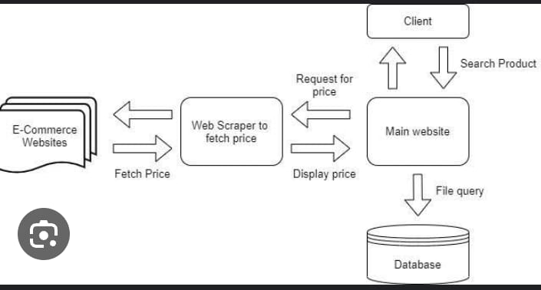

**TOOLS USED:**

* HTML: (To build the structure) HTML is a crucial component of the World Wide Web and is used by web developers to create dynamic and interactive websites.
* CSS: (Used in Styling for Visual Appeal) CSS is used to control the layout, colors, fonts, and other visual aspects of web pages. It allows web developers to separate the presentation style of a document from its content, defined in HTML.

CSS provides a wide range of styling options, including the ability to set background colors and images, control the size and spacing of elements, and specify the font and color of text.

* JavaScript: (Interactivity and Functionality) It has dynamic typing, prototype-based object-orientation, and first-class functions. It is multi-paradigm, supporting event-driven, functional, and imperative programming styles. It has application programming interfaces (APIs) for working with text, dates, regular expressions, standard data structures, and the Document Object Model (DOM).
* Python: (Backend Development) Python is [dynamically typed](https://en.wikipedia.org/wiki/Type_system#DYNAMIC) and [garbage-collected](https://en.wikipedia.org/wiki/Garbage_collection_(computer_science)). It supports multiple [programming paradigms](https://en.wikipedia.org/wiki/Programming_paradigm), including [structured](https://en.wikipedia.org/wiki/Structured_programming) (particularly [procedural](https://en.wikipedia.org/wiki/Procedural_programming)), [object-oriented](https://en.wikipedia.org/wiki/Object-oriented_programming) and [functional programming](https://en.wikipedia.org/wiki/Functional_programming). It is often described as a "batteries included" language due to its comprehensive [standard library](https://en.wikipedia.org/wiki/Standard_library).